**S.Y. BTech (IT)**

**SUB: DBMS LAB**

**Experiment No: 5**

**Study and Implement Subqueries**

**SAP ID: 60003220131 CLASS: I1**

**NAME: Ayush Vinod Upadhyay BATCH: 1**

**------------------------------------------------EXERCISE--------------------------------------------**

**Implement the SQL statements for the following questions**

1. **Create the given tables and insert the respective values in the tables.**

|  |  |  |  |  |  |
| --- | --- | --- | --- | --- | --- |
| Customer Master : CUST | | Movie Master : MOVIE | | Invoice Transaction : INVOICE | |
| Column Name | Format | Column Name | Format | Column Name | Format |
| Cust_id | Varchar2(3) | Movie_no | Integer | Inv_no | Varchar2(3) |
| Lname | Varchar2(15) | Title | Varchar2(15) | Movie_no | Integer |
| Fname | Varchar2(15) | Type | Varchar2(10) | Cust_id | Varchar2(3) |
| Area | Varchar2(2) | Star | Varchar2(25) | Issue_date | Date |
| Phone_no | Integer | Price | Number(8,2) | Return_date | Date |

1. **Insert the following data in the respective tables**

**Data for CUSTOMER table:**

|  |  |  |  |  |
| --- | --- | --- | --- | --- |
| Cust_id | Lname | Fname | Area | Phone_no |
| A01 | Border | Allan | SA | 723622 |
| A02 | Shields | Tina | Mo | 123784 |
| A03 | Kumar | Ravi | BI | 545621 |
| A04 | Rai | Sunita | CH | 983724 |
| A05 |  | Sachin | DR | 253489 |
| A06 | Smith | James | WA | 634672 |

**Data for MOVIE table:**

|  |  |  |  |  |
| --- | --- | --- | --- | --- |
| Movieno | Title | Type | Star | Price |
| 1 | Carry On doctor | Comedy | Leslie Phollips | 175.00 |
| 2 | The Firm | Thriller | Tom Cruise | 200.00 |
| 3 | Pretty Woman | Romance | Richard Gere | 150.55 |
| 4 | Home Alone | Comedy | Macaulay Culkin | 150.00 |
| 5 | The Fugitive | Thriller | Harison Ford | 200.00 |
| 6 | Coma | Suspense | Michael Douglas | 100.00 |
| 7 | Dracula | Horror | Gary Oldman | 150.25 |
| 8 | Quick Change | Comedy | Bill Murray | 190.00 |

**Data for INVOICE Table:**

|  |  |  |  |  |
| --- | --- | --- | --- | --- |
| Inv_no | Movie_no | Cust_id | Issue_date | Return_date |
| I01 | 4 | A01 | 23-jul-95 | 28-jul-95 |
| I02 | 3 | A02 | 12-aug-95 | 15-aug-95 |
| I03 | 1 | A02 | 10-sep-95 | 16-sep-95 |
| I04 | 6 | A03 | 23-jul-95 | 24-jul-95 |
| I05 | 7 | A04 | 28-jul-95 | 29-jul-95 |
| I06 | 2 | A06 | 01-sep-95 | 04-sep-95 |
| I07 | 9 | A05 | 07-aug-95 | 08-aug-95 |
| I08 | 9 | A01 | 18-aug-95 | 22-sep-95 |
| I09 | 5 | A03 | 06-jul-95 | 09-jul-95 |
| I10 | 8 | A06 | 02-aug-95 | 05-aug-95 |

1. Find the lname, fname who have been issued movies.

2. Find out the movie number which has been issued to Allan.

3. Display all the movie title whose price is same as the price of movie ‘The Firm’

4. Find the customer name and area with invoice number ‘I10’.

5. Find the names and movie numbers of all the customers who have been issued a movie.

6. Find out which customers have been issued movie number 9.

7. Find the name of the movie issued to Tina and Allan.

8. List the movie number, movie name issued to all the customers.

9. Find the customer names and phone numbers who have been issued movies before 01-aug-95.

10. Find the type and movie number of movie issued to cust_id ‘A01’ and ‘A02’.

QUERY:

1. SELECT c.fname, c.lname

FROM customer c

INNER JOIN invoice i ON c.cust_id = i.cust_id

INNER JOIN movie m ON i.movie_no = m.movie_no;

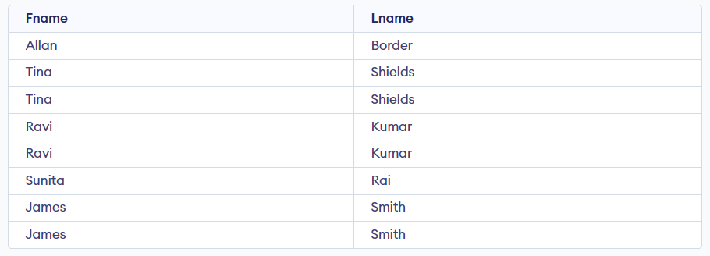

1. SELECT movie_no

From invoice where cust_id=(select cust_id from customer where fname='Allan')

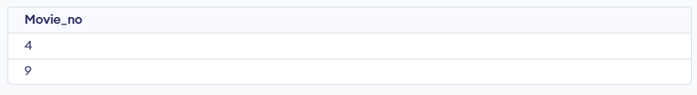

1. SELECT title

FROM movie

WHERE price = (SELECT price FROM movie WHERE title = 'The Firm')

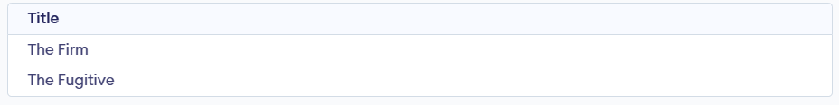

1. SELECT c.lname,c.fname, c.area

FROM customer c

JOIN invoice i ON c.cust_id = i.cust_id

WHERE i.inv_no = 'I10';



1. SELECT c.fname, c.lname, i.movie_no

FROM customer c

INNER JOIN invoice i ON c.cust_id = i.cust_id;

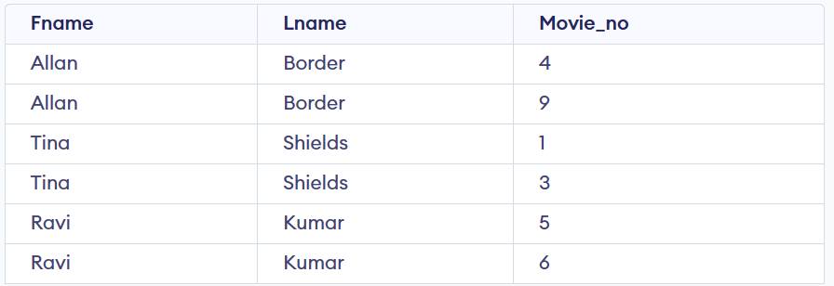

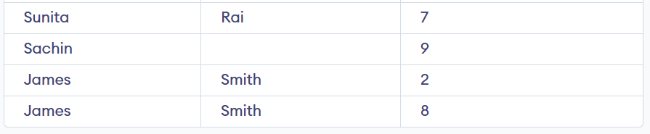

1. SELECT c.*

FROM customer c

INNER JOIN invoice i ON c.cust_id = i.cust_id

WHERE i.movie_no = 9;

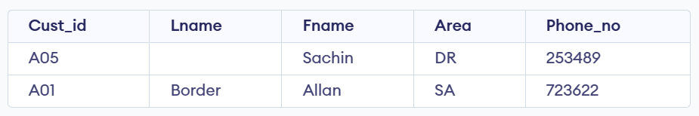

1. SELECT m.title

FROM movie m

INNER JOIN invoice i ON m.movie_no = i.movie_no

INNER JOIN customer c ON c.cust_id = i.cust_id

WHERE c.fname IN ('Tina', 'Allan');

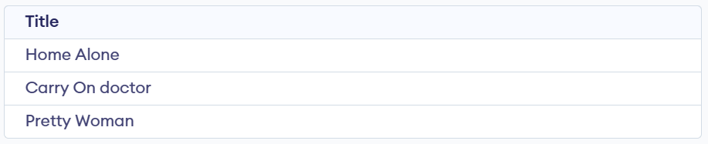

1. SELECT c.fname, c.lname, i.movie_no, m.title

FROM customer c

INNER JOIN invoice i ON c.cust_id = i.cust_id

INNER JOIN movie m ON i.movie_no = m.movie_no;

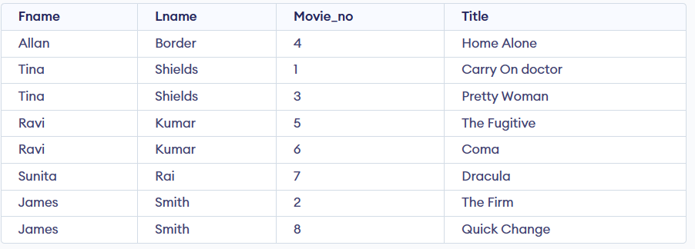

1. SELECT lname, fname, Phone_no

FROM cust

WHERE Cust_id in (SELECT Cust_id FROM INVOICE WHERE Issue_date < ’08-01-1995’);

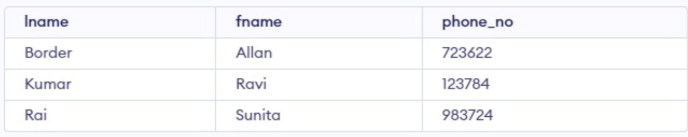

1. SELECT i.cust_id, m.movie_no, m.type

FROM invoice i

INNER JOIN movie m ON i.movie_no = m.movie_no

WHERE i.cust_id IN (select cust_id from customer where cust_id=’A01’ or cust_id=’A02’);

